RECORD

Field | Details
Course | Full Stack Web Development
Course Code | 23CM4121
Experiment No. | 1
Student Name | V Cherishma
Roll No. | A24126552126
Date | 30-08-2026

TITLE
Design a Static Webpage Using Pure Semantic HTML Components

AIM
To design a static webpage using only semantic HTML elements, without any CSS styling, and to demonstrate how browsers structure and render a document based purely on its markup.

OBJECTIVE
The objectives of this experiment are:
  - To understand and apply semantic HTML5 elements such as header, nav, section, main, article, aside and footer.
  - To structure page layout using HTML tables for header and content columns.
  - To create a user inquiry form using native form controls (text, email, select, textarea, submit and reset).
  - To use lists (ordered and unordered) to present structured information.
  - To observe how a browser renders a page relying entirely on default styles.

THEORY
Semantic HTML elements clearly describe their meaning to the browser and to the developer. Tags such as
<header>, <nav>, <section>, <main>, <article>, <aside> and <footer> divide a page into meaningful regions instead of relying on generic <div> containers, which improves accessibility and helps screen readers and search engines interpret the page structure.
HTML tables (<table>, <tr>, <td>) were originally used for tabular data but can also be used for basic page layout, arranging content into rows and columns, as demonstrated here for the header bar and the two-column article/sidebar layout.
HTML forms allow users to submit data using controls such as <input type="text">, <input type="email">,
<select>, and <textarea>, wrapped inside a <fieldset> with a <legend> to group related fields. The required attribute enables built-in browser-side validation without any JavaScript.
Because no CSS is used, the page relies entirely on the browser's default (user-agent) stylesheet for fonts, spacing and colors, which is why headings, links, and form controls appear in their standard unstyled form.

ALGORITHM / PROCEDURE
  - Create a new HTML file and set up the basic document structure with <!DOCTYPE html>, <html>,
<head> and <body>.

  - Inside <header>, create a table with the site title in one cell and a <nav> containing navigation links in another.
  - Add a horizontal rule to visually separate the header from the rest of the page.
  - Create a <section> for the hero/showcase area containing a heading, a short description and a link to the articles section.
  - Build the main two-column layout using a structural <table> with one row and two cells.
  - In the left cell (70% width), add a <main> element containing two <article> blocks describing structural tags and native form elements.
  - Inside the second article, add a <form> with a <fieldset> and <legend>, and include text, email, select and textarea inputs along with submit and reset buttons.
  - In the right cell (30% width, shaded background), add an <aside> with a heading, a paragraph, and an unordered list and an ordered list.
  - Add a footer with a copyright notice centered using the <center> tag.
  - Open the HTML file in a browser and verify that all sections render correctly using only default browser styling.
  - Test the form fields by entering sample values and checking the built-in required-field validation.

PROGRAM

index.html
<!DOCTYPE html>
<html lang="en">
<head>
<meta charset="UTF-8">
<title>Pure Semantic HTML Static Webpage</title>
</head>
<body>

<!-- Header Section -->
<header>
<table width="100%" border="0" cellspacing="0" cellpadding="10">
<tr>
<td>
<h1>StaticWeb</h1>
</td>
<td align="right">
<nav>
<a href="#home">Home</a> &nbsp;|&nbsp;
<a href="#articles">Articles</a> &nbsp;|&nbsp;
<a href="#about">About</a> &nbsp;|&nbsp;
<a href="#contact">Contact Us</a>
</nav>
</td>
</tr>
</table>
</header>

<hr>

<!-- Hero / Showcase Section -->
<section id="home">
<center>
<h2>Semantic Structures Without CSS</h2>
<p>This layout uses raw HTML components to build an organized document hierarchy that browsers can cleanly parse out-of-the-box.</p>
<p><a href="#articles"><b>Read Our Articles Below &darr;</b></a></p>
</center>
</section>

<hr>

<!-- Main Content Layout using a Structural Table -->
<table width="100%" border="0" cellspacing="0" cellpadding="20">
<tr valign="top">

<!-- Left Side: Main Content Column -->
<td width="70%">
<main id="articles">

<article>
<h2>1. Core Structural Tags</h2>
<p>Published: July 7, 2026</p>
<p>When you omit cascading style sheets entirely, the semantic markup handles all of the structural heavy lifting. Elements like <code>&lt;main&gt;</code>,
<code>&lt;article&gt;</code>, and <code>&lt;section&gt;</code> tell screen readers and web scrapers exactly how information flows.</p>
<p>Using raw browser defaults ensures excellent loading performance, perfect accessibility compliance, and absolute structural clarity.</p>
</article>

<br><hr><br>

<article>
<h2>2. Native Interaction Elements</h2>
<p>Published: July 5, 2026</p>
<p>Browsers come equipped with excellent interactive elements by default.
We can capture text inputs, provide multiple-choice configurations, and submit structured information to backend parsers using pure markup.</p>

<h3>Interactive Demonstration Forms</h3>
<form id="contact" action="#" method="post">
<fieldset>
<legend><b>User Inquiry Form</b></legend>
<p>

placeholder="John Doe">
<label for="name">Full Name: </label>
<input type="text" id="name" name="username" required

</p>
<p>

<label for="email">Email Address: </label>
<input type="email" id="email" name="useremail" required>
</p>
<p>
<label for="topic">Inquiry Topic: </label>
<select id="topic" name="usertopic">
<option value="general">General Feedback</option>
<option value="technical">Technical Architecture</option>
<option value="academics">Academic Curriculum</option>
</select>
</p>
<p>
<label for="message">Message Details:</label><br>
<textarea id="message" name="usermessage" rows="5" cols="40" placeholder="Type your notes here..."></textarea>
</p>
<p>
<input type="submit" value="Submit Form Data">
<input type="reset" value="Clear Entries">
</p>
</fieldset>
</form>
</article>

</main>
</td>

<!-- Right Side: Sidebar Column -->
<td width="30%" bgcolor="#f4f4f4">
<aside id="about">

<h3>Document References</h3>
<p>Static pages map data out directly without real-time database queries or processor overhead.</p>

<h4>Core Benefits:</h4>
<ul>
<li>Instant browser painting</li>
<li>Low memory footprints</li>
<li>High data compatibility</li>
</ul>

<h4>Required Components:</h4>
<ol>
<li>Document Type Definition</li>
<li>Semantic Wrapper Blocks</li>
<li>Data Input Control Interfaces</li>
</ol>
</aside>
</td>

</tr>
</table>

<hr>

<!-- Footer Section -->
<footer>
<center>
<p>&copy; 2026 Pure HTML Architecture. Assembled completely without style configurations.</p>
</center>
</footer>

</body>
</html>

CODE EXPLANATION

Code | Explanation
<header>, <nav>, <footer> | Semantic elements marking the page's top banner, navigation links, and bottom footer region.
<section>, <main>, <article>,  <aside> | Semantic containers dividing the page into a hero area, primary content, individual articles, and a sidebar.
<table>/<tr>/<td> (layout) | Used here purely for positioning the header items and the two-column article/sidebar layout, not for tabular data.
<fieldset> / <legend> | Groups related form controls under the "User Inquiry Form" with a visible caption.
required attribute | Triggers the browser's built-in validation, preventing form submission if the  Name or Email field is empty.
<select> / <option> | Provides a dropdown of predefined inquiry topics for the user to choose from.
<textarea> | Provides a multi-line text input for the message details.
<input type="submit"> / <input type="reset"> | Native buttons to submit the form data or clear all entered values.
<ul> / <ol> | Unordered and ordered lists used in the sidebar to present benefits and  required components.

TEST CASES AND EXECUTION DATA
Each section and form control was verified by loading the page in a browser and interacting with it.

Test Case | Feature Tested | Expected Result | Status
TC-01 | Page load | Header, hero section, articles, sidebar and footer render correctly | Pass
TC-02 | Navigation links | Home, Articles, About and Contact Us links are visible and clickable | Pass
TC-03 | Two-column layout | Articles occupy 70% width; sidebar occupies 30% with shaded background | Pass
TC-04 | Form - required fields | Submitting with Name or Email empty is blocked  by the browser | Pass
TC-05 | Form - dropdown and textarea | Inquiry Topic can be selected; Message Details accepts multi-line text | Pass
TC-06 | Reset button | Clicking Clear Entries resets all form fields to blank | Pass

OUTPUT

Output 1: Full Page Layout
The rendered page shows the header with the site title and navigation, the hero section, and the two-column layout with articles on the left and the sidebar on the right, all using unstyled default browser formatting.
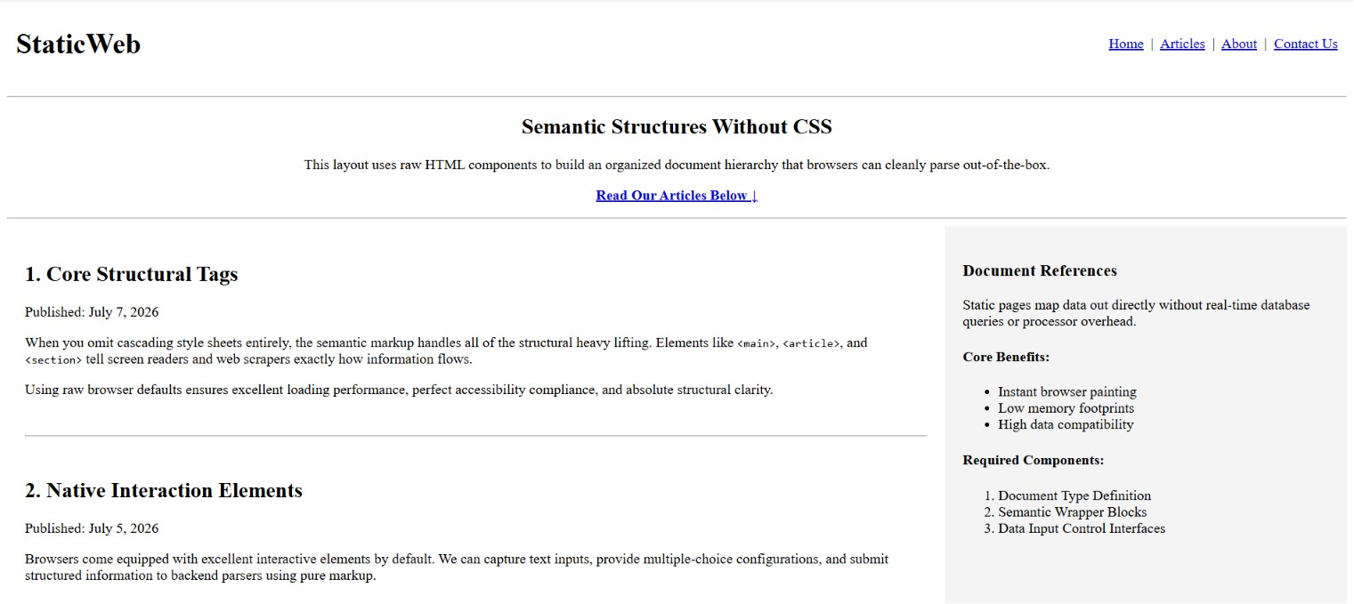
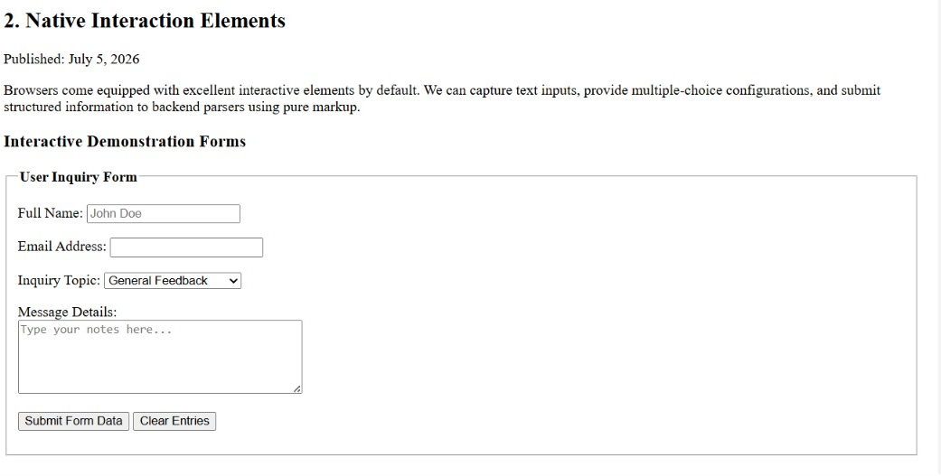

Output 2: User Inquiry Form Filled

The form fields accept user input as expected, with the Full Name, Email Address, Inquiry Topic and Message Details all editable through native browser controls.
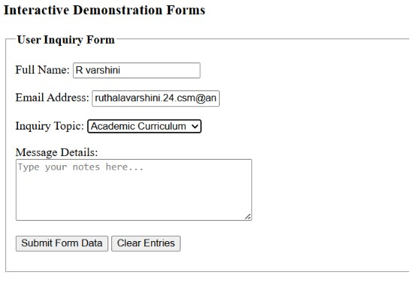

RESULT
Thus, a static webpage was successfully designed using pure semantic HTML components, including header, navigation, section, main, article, aside and footer elements, a table-based layout, and a native HTML form with required-field validation. The page rendered correctly in the browser using only default styling, and all sections and form controls were verified as working as expected.

